EXPERIMENT 2

mkdir prac1
cd prac1

touch exp1
echo "linux" > exp1
echo "iot" >> exp1
echo "dbms" >> exp1
echo "ct" >> exp1

Ls -l

cat exp1
sort exp1
head -2 exp1
tail -2 exp1

touch exp2
echo "exp2" > exp2

ls -l

grep "ct" exp2
awk '{print $1}' exp2

mkdir prac2
ls

rmdir prac2
ls

chmod 755 exp2
ls -l

ps
top

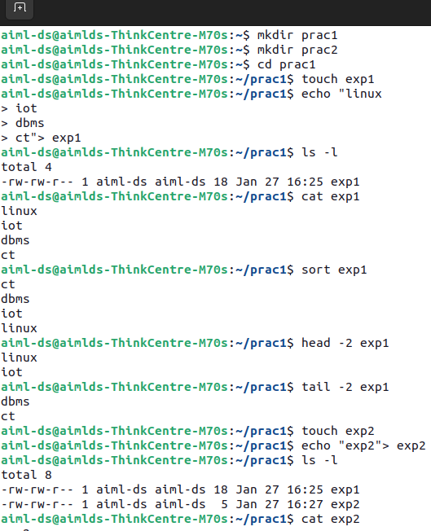
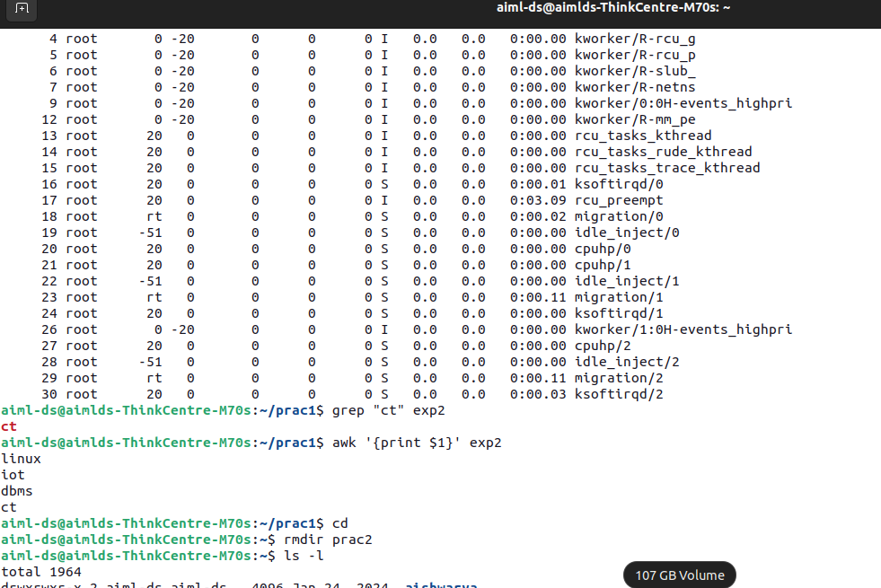

AIM :- To explore the usage of basic Linux commands and Linux system calls for file management,
process management, directory management, and text processing.

RESOURCE REQUIRED
● PC (Pentium IV or above)
● Ubuntu / Linux Operating System
● GCC Compiler
● Terminal
● Printer

THEORY
System Call
A system call is a programmatic interface that allows a user-level process to request services
from the Linux kernel. System calls act as a bridge between user programs and the operating
system, enabling access to hardware resources such as CPU, memory, files, and devices.
Linux supports various system calls for managing processes, files, directories, users, and inter-
process communication.

1. DIRECTORY MANAGEMENT COMMANDS
i) mkdir
Creates a new directory.
mkdir name of the directory
ii) chdir / cd
Changes the current working directory.
cd name of the directory
iii) ls
Lists files and directories.
ls -l

iv)rmdir
remove directory
rmdir directory name
2. FILE MANAGEMENT COMMANDS
i) touch
Create empty file
touch file name
ii) echo
Write content into file
echo “hello friend”&gt;file name
iii) cat
Displays file contents.
cat filename
iv) mv
Copy file content into other file
mv file1 file 2
v) chmod
Changes file permissions.
chmod 755 file name
To check weather permission is apply or not write following command
ls -l filename
vi) chown
Changes file owner.
chown user filename
E.g chown codeuser10003 trial
vii)chgrp
Changes file group.
chgrp group filename

3. PROCESS MANAGEMENT COMMANDS
i) ps
Displays running processes.
ps -ef
ii) top
Displays real-time running processes and system resource usage such as CPU and memory.
top
iii) kill
The kill command is used to terminate a running process using its process ID (PID).
kill pid (e.g kill 1234)
iv) killall
Terminates all processes with a given name.
killall process_name
E.g killall
4. TEXT PROCESSING COMMANDS
sort
Sorts lines of a file.
sort data.txt
grep
Searches for a pattern in a file.
grep &quot;Linux&quot; notes.txt
awk
Processes and extracts text.
awk &#39;{print $1}&#39; file.txt

5. FILE MANAGEMENT SYSTEM CALLS
open()

Opens or creates a file.
read()
Reads data from a file.
write()
Writes data to a file.
close()
Closes an opened file.

6. PROCESS &amp; USER INFORMATION SYSTEM CALLS
getpid()
Returns process ID of calling process.
getuid() / geteuid()
Returns real and effective user ID.
getgid() / getegid()
Returns real and effective group ID.

SAMPLE C PROGRAM (SYSTEM CALLS)
#include &lt;stdio.h&gt;
#include &lt;fcntl.h&gt;
#include &lt;unistd.h&gt;
#include &lt;string.h&gt;
int main() {
int fd;
char data[] = &quot;Linux System Calls Example\n&quot;;
fd = open(&quot;sample.txt&quot;, O_CREAT | O_WRONLY, 0644);
write(fd, data, strlen(data));
close(fd);
printf(&quot;Process ID: %d\n&quot;, getpid());
printf(&quot;User ID: %d\n&quot;, getuid());
printf(&quot;Group ID: %d\n&quot;, getgid());
return 0;
}

OUTPUT
● Directory created successfully
● File created and data written
● Process ID, User ID, and Group ID displayed
● Commands executed successfully

CONCLUSION
Thus, we have successfully explored and executed various Linux commands and system calls
related to file management, directory management, process management, and text
processing, and understood their practical usage in a Linux environment.

